Brandon Bair

**Football Camp**

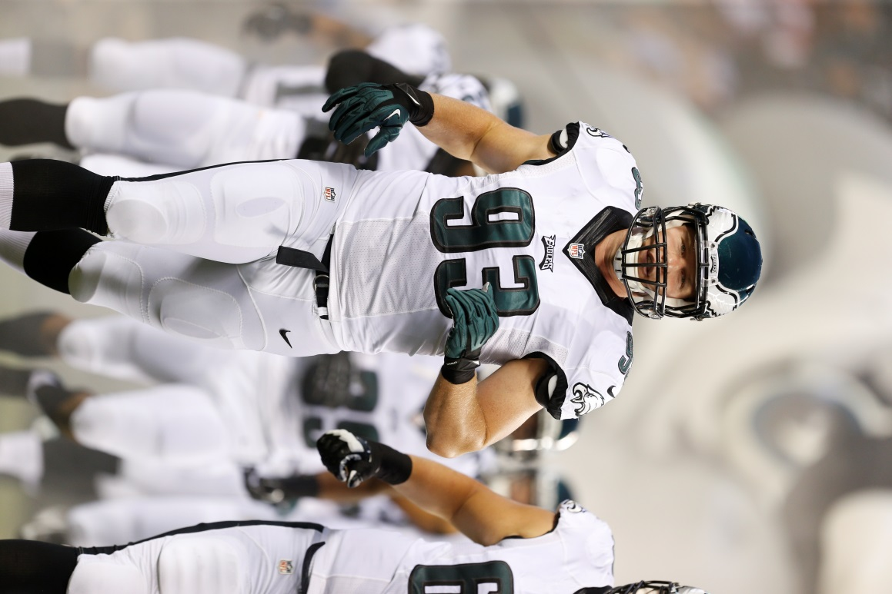July 8 & 9 2015 in Rexburg at

**The Zone**

3rd-5th Grade

Time: 6-8Ppm Cost $50.00

T-shirt included with the cost of camp.

Please bring a water bottle and basketball shoes.

Mail in by Friday June 12, 2015

Brandon Bair Football Camp

275 Stationery Rd

Rexburg, ID 83440

**For questions or information on Brandon’s 6th-12th grade camps:**

**Please visit BrandonBair.com Rexburgzone.com or Call/ Text 208-907-1184**

Please return this portion with payment.

I, (parent/guardian) (Print) _______________________ give my permission to let __________________ (child) participate, in The Brandon Bair Football Camp. This camp does **not** provide insurance and all injury related expenses shall be the responsibility of the participant’s parent/guardian.

Parent/Guardian Signature: ____________________________ Phone__________________ Email_______________________________

Grade_________ Adult Sizes: T- Shirt S M L XL XXL

Youth Sizes: T- Shirt S M L XL

NO refunds will be given. Make checks payable to **The Zone**